**JOBSHEET 6**

**INHERITANCE**

Erwan Majid/08/2i

Link Github: <https://github.com/Majid5654/Semester-3/tree/Main/JAVA%20OOP/Week6>

* **TRIAL 1 (extends)**

ClassA: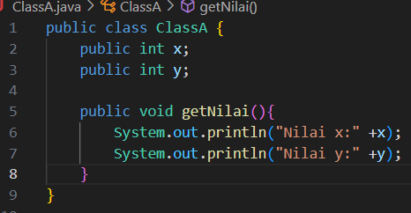

ClassB:

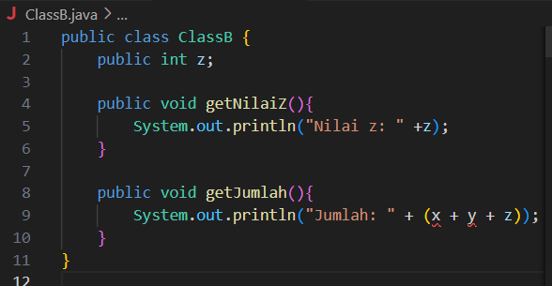

Percobaan1:

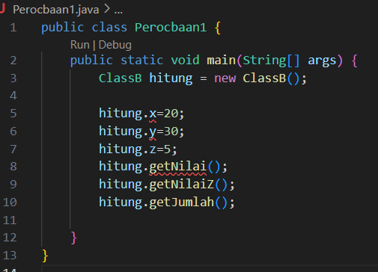

Output:

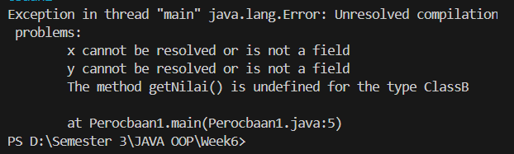

**B. QUESTIONS**

1. In Experiment 1 above the program that was running error occurred, then fix so that the program

can be run and not error! -  
add code extends Class A.

2. Explain what caused the program in experiment 1 when it ran an error!

-It because ClassB access the variables x and y from ClassA, but there is no relationship between the two classes. To fix this, it need to make ClassB extend ClassA, so that ClassB can inherit the fields x and y from ClassA

* **TRIAL 2 (Access Control)**

ClassA:

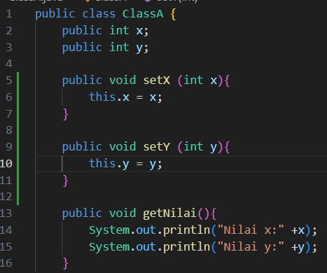

ClassB:

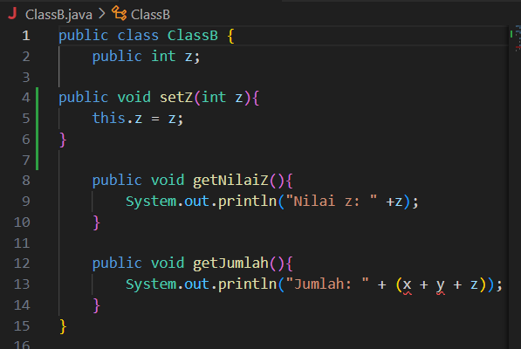

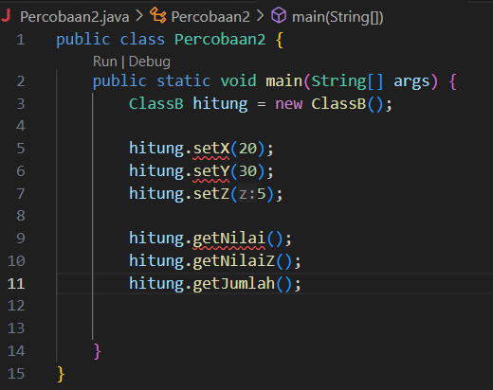 Main:

Output:

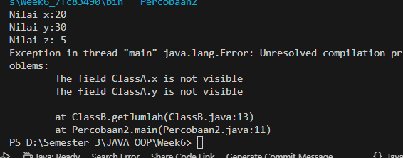

**B. QUESTIONS**

1. In Experiment 2 above, the program that runs an error occurs, then fix it so that the program can be run and not error! -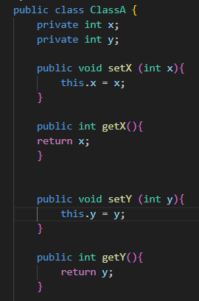

-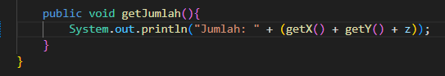

2. Explain what caused the program in experiment 1 when it ran an error!

-Since the variables x and y in ClassA are private, the class ClassB cannot directly access them. We can access the values ​​of x and y through the getter methods (getX() and getY()).

* **TRIAL 3 (Super)**

Bangun:

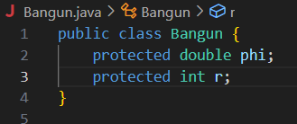

Tabung:

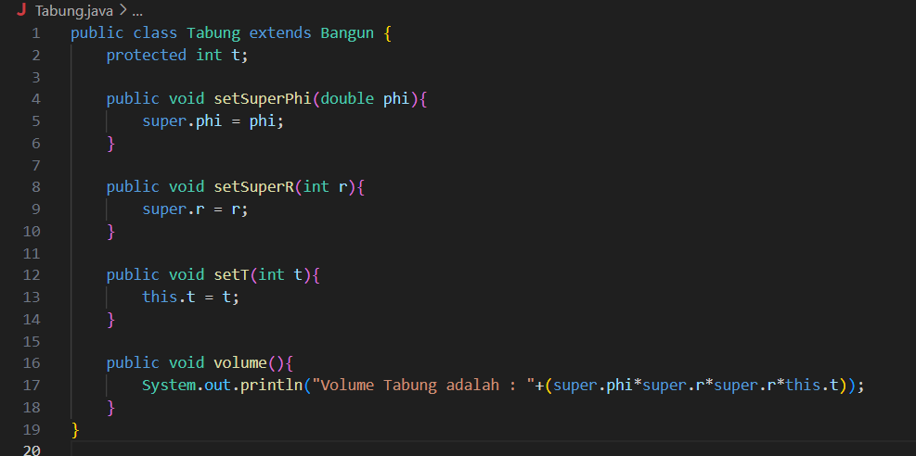

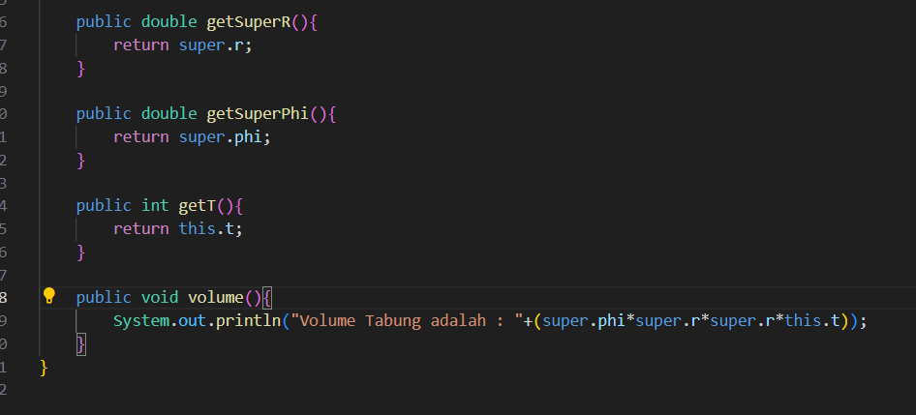

Main:

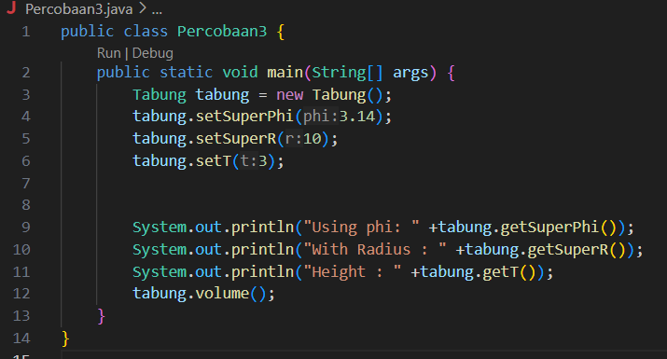

Output:

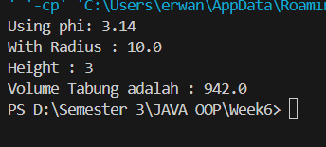

**QUESTIONS**

1. Explain the "super" function in the following program snippet in the Tube class!

-super refers to the superclass (parent class) of the current class. Tabung is a subclass that extends Bangun. The fields phi and r defined in the Bangun class. When it call super.phi and super.r belong to the Bangun class and are being inherited into the Tabung class

2. Explain the "super" and "this" functions in the following program snippet in the Tube class

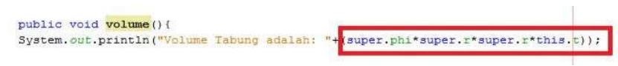  
-if ‘super’ its reference to the parent class and are being inherited into tabung class,then ‘this’,is Initializes fields that belong to the current class

3. Explain why the Tube class does not declare the "phi" and "r" attributes, but the class can access these attributes!

-because these attributes are inherited from its superclass (Bangun) and in the tube class extends Bangun. Inheritance is designed to promote code reuse

* **TRIAL 4 (super contructor)**

ClassA:

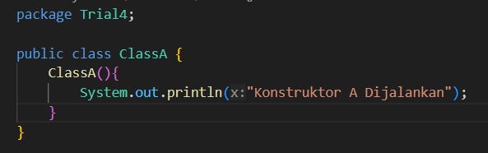

ClassB:

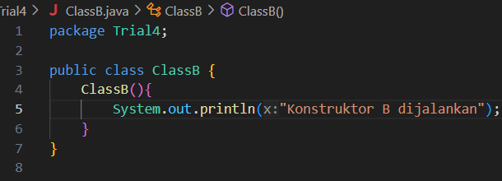

ClassC:

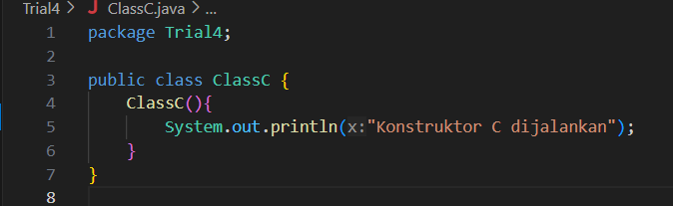

Main:

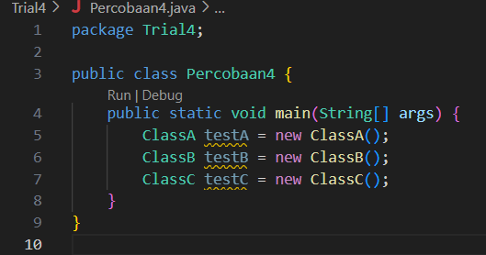

Output:

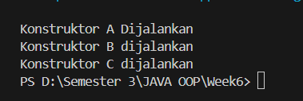

**QUESTIONS**

1. In experiment 4 state which class includes the superclass and subclass, then explain the reason!

-none of the classes explicitly include the concepts of superclass or subclass. All classes are independent and do not have an inheritance relationship with each other

2. Change the contents of the ClassC default constructor as follows: 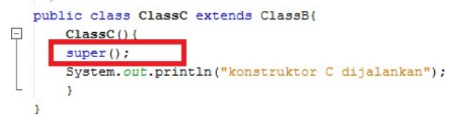

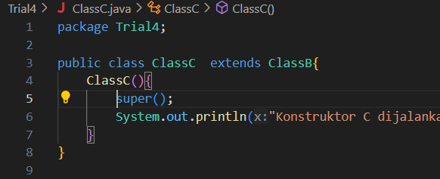

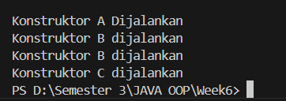

Add the word super () in the First row in the default constructor. Try running the Experiment 4 class

again and it looks like there is no difference from the output!

Explain how the order of the constructor goes when the test object is created! -The constructor call order ensures that the superclass (in this case, ClassB) is initialized before the subclass (ClassC). This order is important to ensure that any inherited properties or behaviors in the subclass are properly set up by the superclass before the subclass-specific code is executed.

4. What is the super () function in the following program snippet in ClassC

-The super() function in this program snippet from ClassC explicitly invokes the constructor of the superclass (ClassB). It ensures that ClassB is initialized properly before the ClassC constructor continues its execution, maintaining the proper order of initialization in the inheritance hierarchy.

**ASSIGNMENTS**

DaftarGaji:

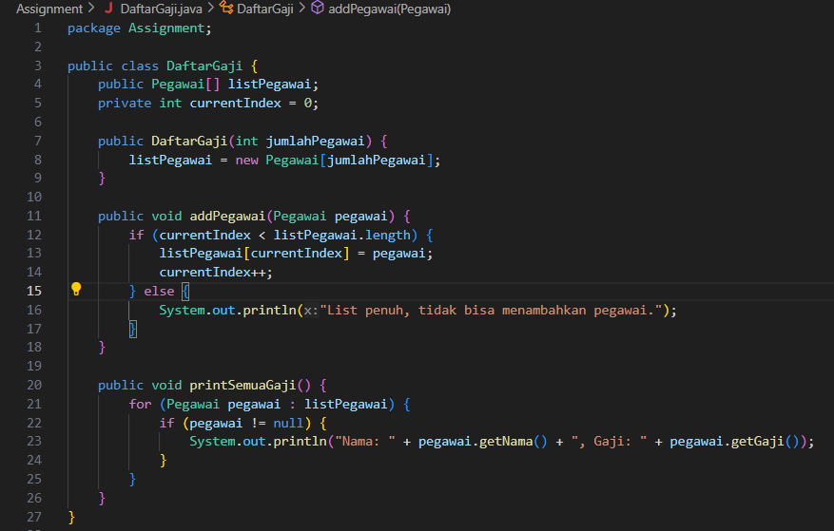

Pegawai:

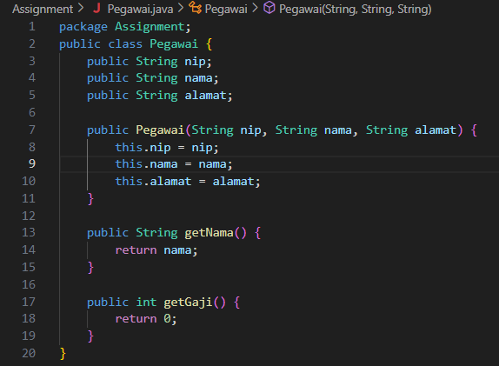

Dosen:

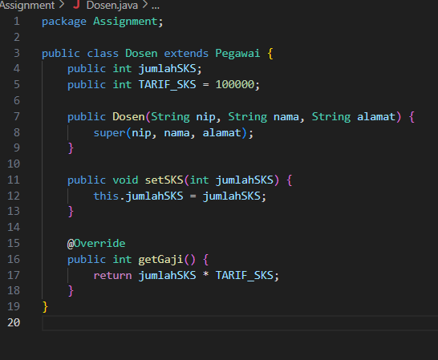

Main:

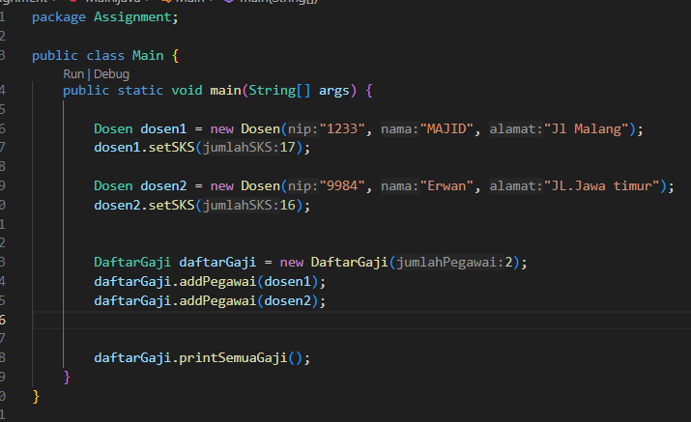

Output:

